The Style Invitational Week 813 Aw Shocks
Saturday, April 18, 2009

I was shocked, shocked when I was vacationing in the Virgin Islands and learned that the nice girl I invited to my hotel room was not a virgin!

As Capt. Renault noted so famously and disingenuously in "Casablanca" about gambling at Rick's Café Américain, there's the shocking and then there's the "shocking -- not." This week: Give us a humorous example of the latter, as in the example above by 10-time Loser Richard Lempert of Arlington, who suggested this contest.

Winner gets the Inker, the official Style Invitational trophy. Second place receives two cans of genuine Porcari Sweat, a Japanese energy drink, donated by 259-time Loser Peter Metrinko. We will also be happy to accept donations of Porcari Phlegm and Porcari Earwax.

Other runners-up win a coveted Style Invitational Loser T-shirt. Honorable Mentions get one of the lusted-after Style Invitational Magnets. First Offenders get a smelly tree-shaped air "freshener" (Fir Stink for their First Ink). One prize per entrant per week. Send your entries by e-mail to losers@washpost.comor by fax to 202-334-4312. Deadline is Monday, April 27. Put "Week 813" in the subject line of your e-mail, or it risks being ignored as spam. Include your name, postal address and phone number with your entry. Contests are judged on the basis of humor and originality. All entries become the property of The Washington Post. Entries may be edited for taste or content. Results will be published May 16. No purchase required for entry. Employees of The Washington Post, and their immediate relatives, are not eligible for prizes. Pseudonymous entries will be disqualified. This week's Honorable Mentions name is by Dave Prevar; the revised title for next week's results is by Kevin Dopart.

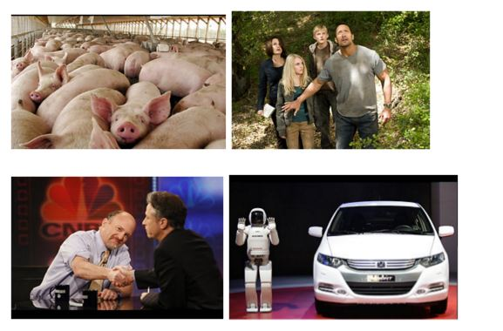Report from Week 809, in which we asked you to supply cutlines -- or captions, as they're known outside the newspaper world -- for the photos above (on the Web, you can see them on the slide show at right). Too many people were reminded by Photo A of hamming it up at the "American Idol" tryouts, while the most common quote prompted by the Rock and fellow cast members in Photo B was "Which mountain?" and, not surprisingly given the season, everyone thought of ancient Easter egg hunts.

The Winner of the Inker

Photo D: "Don't shoot -- the keys are in my left back socket." (Elizabeth Molyé, Arlington)

2.Photo C: Jim Cramer offers a manly handshake to Jon Stewart to distract audience attention from his newly ripped orifice. (Jean Bonner, Chantilly)

3. Photo D: Hopes were dashed at Asimo Robotics when the Robbie 2009 flunked its driver's test at Step 1: "Failure to locate vehicle." (Martin Bancroft, Rochester, N.Y.)

4. Photo A: Capitol Police have apologized to pork stuck in the Fourth Street tunnel during the historic stimulus bill. (Ben Aronin, Washington)

The Cut Lines: Honorable Mentions

PHOTO A

It dawns on Arnold that "this little piggy goes to market" might not mean he's going shopping. (Larry Yungk, Arlington)

Preparations begin for the annual Running of the Pigs in South Pamploma, Iowa. (Jeff Brechlin, Eagan, Minn.)

Babe finds out what happens to pigs "that won't do." (Larry Yungk)

The sagging economy has produced a sharp uptick in sow-ear values. (Larry Carnahan, Arlington)

Wilbur now regrets that he did not teach Charlotte's kids how to write. (Larry Yungk)

House Democrats meet to approve $875 billion in this year's budget for earmarks for their home districts. (Ronald Nessen, Bethesda, a First Offender [yes, the same one])

Deeming it too cute for sophisticated Style Invitational readers, the pig submitted his photo to the Harrisburg Patriot-News instead. (Richard Wong, Derwood)

PHOTO B

"Really, Dad, he's very sweet," Kayla reassured her father as Tyler arrived to take her bowling. (Ross Elliffe, Picton, New Zealand)

"Hand me the script, slowly -- they can smell the fear when you've forgotten your lines." (Russ Taylor, Vienna)

Juneau resident John Danvers warns his family not to make any sudden movements until Sarah Palin's helicopter is out of sight. (Jennifer Rubio, Oakton)

"You guys run for it -- I'm due for a colonoscopy anyway." (Tom Murphy, Bowie)

PHOTO C

Jim Cramer considered his arm-wrestling bout with Jon Stewart a mere warm-up before facing the women on "The View." (Mike Ostapiej, Tracy, Calif.)

Stewart falls for the old booger-in-the-handshake trick. (Ned Bent, Oak Hill)

"Jon, can they move the camera so I don't have to hunch over to not block my employer's logo?" (Russ Taylor)

After years of sharing fake news, CNBC formalizes its merger with the Comedy Channel. (Ira Allen, Bethesda)

Jon Stewart interviews an actual toxic asset. (Jay Shuck, Minneapolis)

PHOTO D

Helpless because it had no hands to "raise in the air," the car lost yet another round of Simon Says. (Jeff Brechlin)

Asimo finds that, sadly, robot proms are just as awkward as the human ones. (Kevin Dopart)

The new Insight comes with a "slug" for quicker commuting. (Rick Haynes, Potomac)

The gang at the MIT mixer lines up for the Chicken Dance. (Jeff Brechlin)

At Honda, they use only crash test smarties. (Larry Yungk)

GM's new CEO is prepared to work 24/7 and will forgo all bonuses till 2012. (Howard Walderman, Columbia)

While it is no longer popular among sentient humans, the inanimate still enjoy the Macarena. (Russell Beland, Fairfax)

"My other car is a Large Hadron Collider." (Peter McMenamin, Silver Spring, a First Offender)

PHOTO E

It's the egg! The egg came first! (Dudley Thompson, Cary, N.C.)

Archaeologist Martha Diggs displays evidence that even in brontosauruses, size of the footprint isn't much of a clue. (David Safavian, Alexandria)

Paleontologist Ellie Sattler proves that Tyrannosaurus Rex had nipples. (Kevin Dopart)

Prudence Alwaze, who got out of the stock market in 2007 and closed her account with Bernard Madoff in 2008, prepares to place her nest egg in the safest location she can find. (Dick Barnes, Washington)

Alexandra L. Bancroft PhD, author of "Transgressive Tropes in Late-Period Chaucer," delights in finding two truffles as part of the White House stimulus package for furloughed humanities professors. (John Shea, Lansdowne, Pa.)

PHOTOS A, B, C AND D: As soon as they expand the definition of marriage again, they're set. (Jeffrey Contompasis, Ashburn)

Next Week: What Kind of Foal Am I, or The Jokey Club

